<!DOCTYPE html>

<html lang="en">

<head>

  <meta charset="UTF-8" />

  <meta name="viewport" content="width=device-width, initial-scale=1.0"/>

  <title>Student Admission Interface</title>

  <link href="https://cdn.jsdelivr.net/npm/bootstrap@5.3.2/dist/css/bootstrap.min.css" rel="stylesheet" />

</head>

<body style="color: #333; font-family: Arial, sans-serif; background-color: #f8f9fa;">

  <!-- Header -->

  <header style="background-color: #b10000; padding: 20px; box-shadow: 0 4px 8px rgba(0, 0, 0, 0.2); margin-bottom: 20px;">

    <h1 style="color: white; text-align: center; margin: 0; font-size: 2.5em; text-shadow: 2px 2px 4px rgba(0,0,0,0.3);">

      Student Admission Interface

    </h1>

  </header>

  <!-- Main Content -->

  <div class="container">

    <section style="background-color: white; padding: 25px; margin: 30px auto; border-radius: 15px; box-shadow: 0 2px 10px rgba(0,0,0,0.1); border-top: 10px solid #b10000;">

      <h2 class="mb-4 text-center" style="color: #b10000;">Admission Form</h2>

      <form action="/submit" method="post" enctype="multipart/form-data">

        <!-- Personal Information -->

        <div class="card mb-4">

          <div class="card-body">

            <fieldset>

              <legend class="text-danger">Personal Information</legend>

              <div class="row g-4">

                <div class="col-md-8">

                  <div class="mb-3">

                    <label for="firstName" class="form-label">First Name <span class="text-danger">*</span></label>

                    <input type="text" class="form-control" id="firstName" placeholder="Juan" required>

                  </div>

                  <div class="mb-3">

                    <label for="lastName" class="form-label">Last Name <span class="text-danger">*</span></label>

                    <input type="text" class="form-control" id="lastName" placeholder="Dela Cruz" required>

                  </div>

                  <div class="mb-3">

                    <label for="email" class="form-label">Email Address <span class="text-danger">*</span></label>

                    <input type="email" class="form-control" id="email" placeholder="juan.delacruz@example.com" required>

                  </div>

                  <div class="mb-3">

                    <label for="phoneNumber" class="form-label">Phone Number <span class="text-danger">*</span></label>

                    <input type="tel" class="form-control" id="phoneNumber" placeholder="Enter your phone number ex. 09123456789" pattern="[0-9]{11}" required>

                  </div>

                  <div class="mb-3">

                    <label for="dateOfBirth" class="form-label">Date of Birth <span class="text-danger">*</span></label>

                    <input type="date" class="form-control" id="dateOfBirth" required>

                  </div>

                  <div class="mb-3">

                    <label for="street" class="form-label">Home Number / Street Name <span class="text-danger">*</span></label>

                    <input type="text" class="form-control" id="street" placeholder="25 Mapanganib St." required>

                  </div>

                  <div class="row">

                    <div class="col-md-6 mb-3">

                      <label for="barangay" class="form-label">Barangay <span class="text-danger">*</span></label>

                      <input type="text" class="form-control" id="barangay" placeholder="Malandi" required>

                    </div>

                    <div class="col-md-6 mb-3">

                      <label for="city" class="form-label">City / Municipality <span class="text-danger">*</span></label>

                      <input type="text" class="form-control" id="city" placeholder="Maharot City" required>

                    </div>

                  </div>

                  <div class="row">

                    <div class="col-md-6 mb-3">

                      <label for="province" class="form-label">Province <span class="text-danger">*</span></label>

                      <input type="text" class="form-control" id="province" placeholder="Laguna" required>

                    </div>

                    <div class="col-md-6 mb-3">

                      <label for="zip" class="form-label">ZIP Code <span class="text-danger">*</span></label>

                      <input type="text" class="form-control" id="zip" placeholder="1811" required>

                    </div>

                  </div>

                </div>

                <!-- Photo Upload, Gender, Program -->

                <div class="col-md-4">

                  <div class="card">

                    <div class="card-body">

                      <h5 class="card-title text-danger text-center">Photo Upload</h5>

                      <div class="mb-3 d-flex justify-content-center">

                        <div style="border: 2px dashed #b10000; border-radius: 10px; padding: 10px; background-color: #f8d7da; max-width: 150px; width: 100%;">

                          <img src="../images/user.png" alt="Placeholder Image" style="width: 100%; height: auto; border-radius: 10px;">

                        </div>

                      </div>

                      <label for="photo" class="form-label">Insert Photo <span class="text-danger">*</span></label>

                      <input type="file" id="photo" name="photo" accept="image/*" required class="form-control mb-3">

                    </div>

                  </div>

                  <div class="card mt-4">

                    <div class="card-body">

                      <h5 class="card-title text-danger text-center">Gender</h5>

                      <div class="form-check">

                        <input type="radio" id="GenderMale" name="gender" value="male" required class="form-check-input">

                        <label for="GenderMale" class="form-check-label">Male</label>

                      </div>

                      <div class="form-check">

                        <input type="radio" id="GenderFemale" name="gender" value="female" required class="form-check-input">

                        <label for="GenderFemale" class="form-check-label">Female</label>

                      </div>

                    </div>

                  </div>

                  <div class="card mt-4">

                    <div class="card-body">

                      <h5 class="card-title text-danger text-center">Program Selection</h5>

                      <div class="mb-3">

                        <label for="college" class="form-label">Select College <span class="text-danger">*</span></label>

                        <select id="college" name="college" class="form-select" required>

                          <option value="" disabled selected>Select your college</option>

                          <option value="coe">College of Engineering</option>

                          <option value="cas">College of Arts and Sciences</option>

                          <option value="cba">College of Business Administration</option>

                          <option value="ccis">College of Computer and Information Science</option>

                        </select>

                      </div>

                      <div class="mb-3">

                        <label for="course" class="form-label">Select Course <span class="text-danger">*</span></label>

                        <select id="course" name="course" class="form-select" required>

                          <option value="" disabled selected>Select your course</option>

                          <option value="bsit">BS Information Technology</option>

                          <option value="bsce">BS Civil Engineering</option>

                          <option value="bsa">BS Accountancy</option>

                          <option value="bspsyc">BS Psychology</option>

                        </select>

                      </div>

                    </div>

                  </div>

                </div>

              </div>

            </fieldset>

          </div>

        </div>

        <!-- Academic Info -->

        <div class="card mb-4">

          <div class="card-body">

            <fieldset>

              <legend class="text-danger">Academic Information</legend>

              <div class="row g-4">

                <div class="col-md-12">

                  <div class="mb-3">

                    <label for="COR" class="form-label">Insert COR <span class="text-danger">*</span></label>

                    <input type="file" id="COR" name="COR" accept="image/*" required class="form-control mb-3">

                    <div class="mb-3">

                      <label for="schoolName" class="form-label">Previous School Name <span class="text-danger">*</span></label>

                      <input type="text" class="form-control" id="schoolName" required>

                    </div>

                    <div class="mb-3">

                      <label for="schoolStreet" class="form-label">Previous School Street <span class="text-danger">*</span></label>

                      <input type="text" class="form-control" id="schoolStreet" required>

                    </div>

                    <div class="row">

                      <div class="col-md-6 mb-3">

                        <label for="schoolBarangay" class="form-label">Barangay <span class="text-danger">*</span></label>

                        <input type="text" class="form-control" id="schoolBarangay" required>

                      </div>

                      <div class="col-md-6 mb-3">

                        <label for="schoolCity" class="form-label">City / Municipality <span class="text-danger">*</span></label>

                        <input type="text" class="form-control" id="schoolCity" required>

                      </div>

                    </div>

                    <div class="row">

                      <div class="col-md-6 mb-3">

                        <label for="yearGrad" class="form-label">Year Graduated <span class="text-danger">*</span></label>

                        <select id="yearGrad" name="yearGrad" class="form-select" required>

                          <option value="" disabled selected>Select your year graduated</option>

                          <option value="2020">2020</option>

                          <option value="2021">2021</option>

                          <option value="2022">2022</option>

                        </select>

                      </div>

                      <div class="col-md-6 mb-3">

                        <label for="strand" class="form-label">Strand <span class="text-danger">*</span></label>

                        <select id="strand" name="strand" class="form-select" required>

                          <option value="" disabled selected>Select your strand</option>

                          <option value="stem">STEM</option>

                          <option value="abm">ABM</option>

                          <option value="humss">HUMSS</option>

                          <option value="gas">GAS</option>

                        </select>

                      </div>

                    </div>

                  </div>

                </div>

              </div>

            </fieldset>

          </div>

        </div>

        <!-- Additional Info -->

        <div class="card mb-4">

          <div class="card-body">

            <fieldset>

              <legend class="text-danger">Additional Information</legend>

              <div class="row g-4">

                <div class="col-md-12">

                  <div class="row">

                    <div class="col-md-6 mb-3">

                      <label for="fatherFirstName" class="form-label">Father's First Name <span class="text-danger">*</span></label>

                      <input type="text" class="form-control" id="fatherFirstName" placeholder="Rico" required>

                    </div>

                    <div class="col-md-6 mb-3">

                      <label for="motherLastName" class="form-label">Father's Last Name <span class="text-danger">*</span></label>

                      <input type="text" class="form-control" id="motherLastName" placeholder="Dela Cruz" required>

                    </div>

                  </div>

                  <div class="row">

                    <div class="col-md-6 mb-3">

                      <label for="motherFirstName" class="form-label">Mother's First Name <span class="text-danger">*</span></label>

                      <input type="text" class="form-control" id="motherFirstName" placeholder="Maria" required>

                    </div>

                    <div class="col-md-6 mb-3">

                      <label for="motherLastName" class="form-label">Mother's Last Name <span class="text-danger">*</span></label>

                      <input type="text" class="form-control" id="motherLastName" placeholder="Dela Cruz" required>

                    </div>

                  </div>

                  <div class="mb-3">

                    <label for="familyAnnualIncome" class="form-label">Family Annual Income <span class="text-danger">*</span></label>

                    <select id="familyAnnualIncome" name="familyAnnualIncome" class="form-select" required>

                      <option value="" disabled selected>Select your family annual income</option>

                      <option value="0-40000">0 - 40,000</option>

                      <option value="40001-80000">40,001 - 80,000</option>

                      <option value="80001-120000">80,001 - 120,000</option>

                      <option value="120001-above">120,001 and above</option>

                    </select>

                  </div>

                  <div class="row">

                    <div class="col-md-6 mb-3">

                      <label for="emergencyContact" class="form-label">Emergency Contact Name <span class="text-danger">*</span></label>

                      <input type="text" class="form-control" id="emergencyContact" placeholder="Elsa Yelo" required>

                    </div>

                    <div class="col-md-6 mb-3">

                      <label for="emergencyContactNumber" class="form-label">Emergency Contact Number <span class="text-danger">*</span></label>

                      <input type="tel" class="form-control" id="emergencyContactNumber" placeholder="ex.09123456789" pattern="[0-9]{11}" required>

                    </div>

                  </div>

                  <div class="mb-3">

                    <label for="reasons" class="form-label">Why did you choose our University? <span class="text-danger">*</span></label>

                    <textarea class="form-control" id="reasons" rows="3" placeholder="Please specify your reasons." required></textarea>

                  </div>

                </div>

              </div>

            </fieldset>

          </div>

        </div>

        <div class="form-check d-flex justify-content-center align-items-center gap-2 mt-4">

          <input class="form-check-input" type="checkbox" id="agreeTerms" required>

          <label class="form-check-label mb-0" for="agreeTerms">

            I agree to the <a href="#" class="text-danger">terms and conditions</a> <span class="text-danger">*</span>

          </label>

        </div>

        <div class="mt-4 text-center">

          <button type="submit" class="btn btn-danger px-5">Submit Application</button>

        </div>

      </form>

    </section>

  </div>

</body>

</html>

**CONFIRMATION**

<!DOCTYPE html>

<html lang="en">

<head>

  <meta charset="UTF-8" />

  <meta name="viewport" content="width=device-width, initial-scale=1.0"/>

  <title>Confirmation | Student Admission</title>

  <link href="https://cdn.jsdelivr.net/npm/bootstrap@5.3.2/dist/css/bootstrap.min.css" rel="stylesheet" />

</head>

<body style="color: #333; font-family: Arial, sans-serif; background-color: #f8f9fa;">

  <header style="background-color: #b10000; padding: 20px; box-shadow: 0 4px 8px rgba(0, 0, 0, 0.2); margin-bottom: 20px;">

    <h1 style="color: white; text-align: center; margin: 0; font-size: 2.5em; text-shadow: 2px 2px 4px rgba(0,0,0,0.3);">

      Student Admission Interface

    </h1>

  </header>

  <div class="container">

    <section style="background-color: white; padding: 30px; margin: 30px auto; border-radius: 15px; box-shadow: 0 2px 10px rgba(0,0,0,0.1); border-top: 10px solid #b10000; max-width: 800px;">

      <div class="text-center">

        <img src="../images/check.png" alt="Success" style="width: 100px; margin-bottom: 20px;">

        <h2 class="text-success">Application Submitted Successfully!</h2>

        <p class="lead">Thank you for submitting your admission form. We have received your application and will contact you via email for the next steps.</p>

        <div class="mt-4">

          <a href="index.html" class="btn btn-danger">Back to Home</a>

        </div>

      </div>

    </section>

  </div>

</body>

</html>

**OUTPUT**

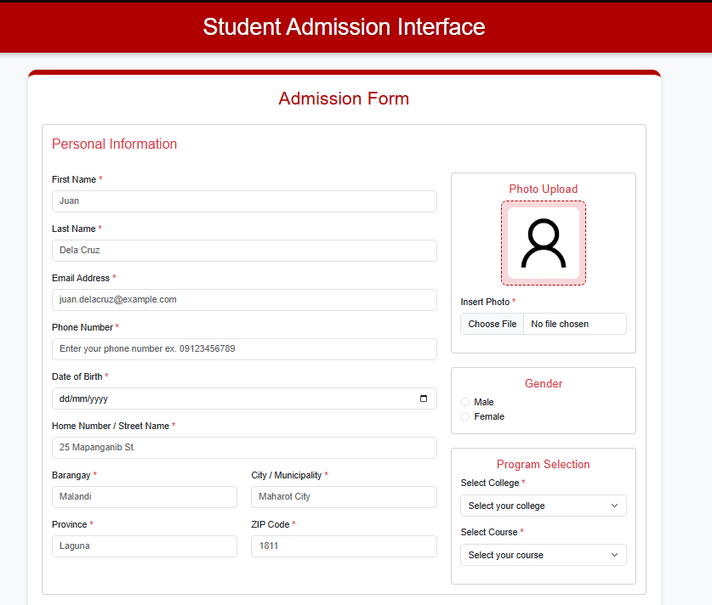

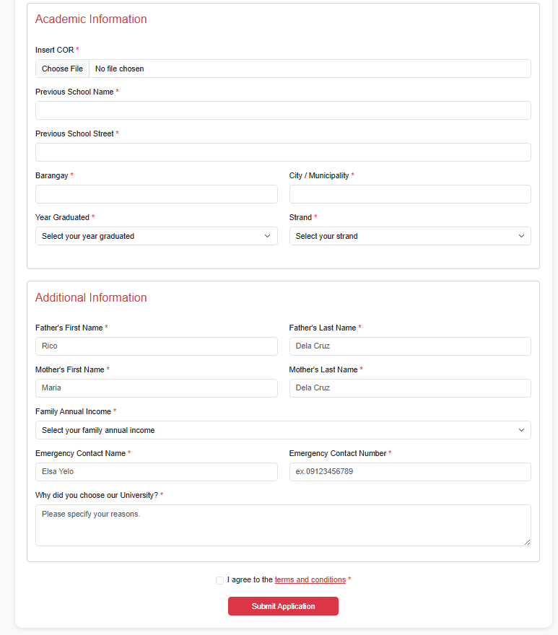

**CONFIMATION**



**OUTPUT WITH VALUES**

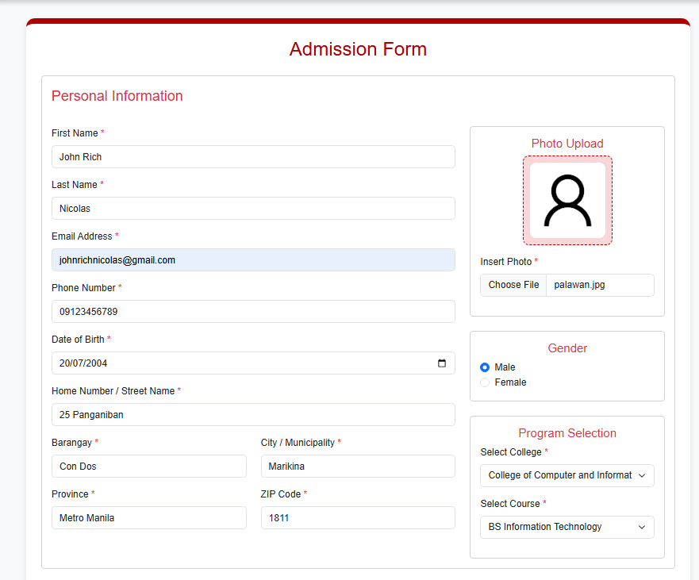

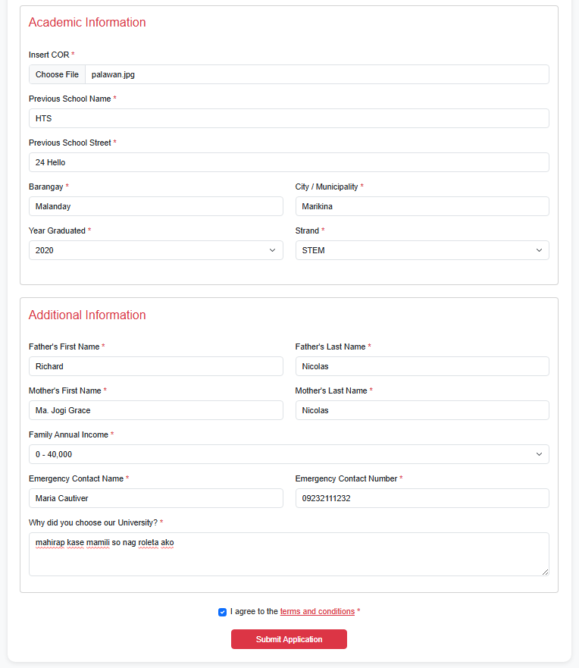

**INPUT VALIDATION**

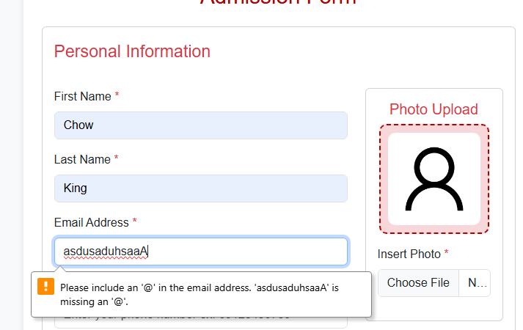

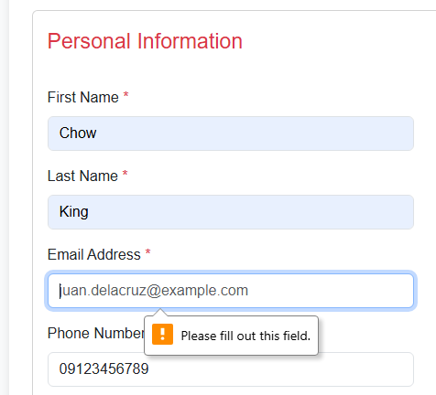

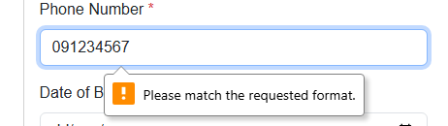

**REFLECTION**

For this project, I created an HTML-based Student Admission Form and structured it using <fieldset> and <legend> elements to group related information together. This helped me organize the form into clear sections like Personal Information, Academic Information, and Additional Information so it's easier for users to fill out. I used Bootstrap 5 and explored its documentation to understand how to implement things like responsive grids and cards. That’s also where I discovered the card component, which I used especially for the photo upload and gender/program sections to make them stand out a bit more.

For the input fields, I chose different types depending on the kind of data needed. I used text boxes for names and addresses, a date picker for birth date, radio buttons for gender, dropdowns for courses, and even a textarea for applicants to explain why they chose the university. There’s also file upload for photos and credentials. I made sure to include required attributes to make sure no important field is skipped, and I used the pattern attribute for phone numbers to make sure users enter exactly 11 digits. I also used id, name, and for properly so the labels are connected to their inputs for better accessibility.

I also created a simple confirmation.html page that displays a success message after submission, just to make the form feel more complete and more user-friendly. I tested the form myself multiple times and made sure that every input works, every required field triggers validation, and that the layout looks clean both on desktop and smaller screens.

One of the challenges I faced was that when I switched to using <fieldset>, the borders I had before disappeared, so I had to adjust styling to make everything still look good. Another thing was I actually started late because of an electrical shortage in our street, so I had to manage my time carefully to try finish everything on time. Still, I’m happy with how the form turned out, and I learned a lot from digging through the Bootstrap docs and applying them to a real layout.